## 

## 

## 

## 

## 

## 

Stoic Solutions

## 

## 

## 

## 

## 

## 

## 

Team (stoicsolutionscsusm@gmail.com):

Adam Hebel, Brian Rattanasith, Chris Bertram, Connor Myers,

Enrique Jimenez, Jerry Compton, Jordan Mower, Matthew Adamus

**Table of Contents**

**1. Application Development** 3

1.1 Statement of Business Context 3

1.2 Statement of Customer’s Business Problem 3

1.3 Statement of Project Proposal 3

1.4 Statement of Deliverables 3

1.5 Measures of Success 4

1.6 System Overview 4

**2. Requirements Matrix** 6

**3. Project Management** 7

3.1 Product Breakdown Structure 7

3.2 Work Breakdown Structure 8

3.3 Initial Schedule for Tasks and Deliverables 9

3.4 Statement of Total Price 12

3.5 Gantt Chart 13

3.6 Initial Project Cost Tracking Chart 15

3.7 Statement of Deliverables 16

3.8 Outline of Resources Needed 16

To: Dr. Kristin Stewart, Assistant Professor of Marketing

CC: Dr. Shaun-inn Wu, Director of Projects

Stoic Solutions is thrilled to be a part of this amazing project for Keep America Beautiful. Thank you, Dr. Stewart, for providing us with this opportunity to be a part of not only a fun and engaging project but also a great cause. We looked forward to continuing our work with you this semester and making this project come to fruition.

The third phase involved the team finalizing the database structure by creating the bone works through an ERD and fine tuning the image collection algorithm for final use; the team also gathered enough images to begin converting them into data in the database. In the next phase we plan to create the database and begin passing images into the machine learning algorithm to get the data desired into the database and ready to use.

Regarding the accrued and projected cost of this project. Our team will be operating at a rate of $28.00 per hour. The estimated cost of Phase 3 was $4,177.80 but the actual cost was $3,444.00. Our estimated total cost, which includes our hourly rate and the cost of running the AWS server, amounts to $15,889.1‬0 after the actual costs of Phase 1, 2 and 3 have been calculated.

A copy of this report will be submitted to both Dr. Stewart and Dr. Wu

By signing below, you hereby approve Stoic Solutions to continue working on the following project: Keeping America Beautiful: Litter Detective and agree to the aforementioned estimated costs.

Thank you,

Chris Bertram (Project Lead)

stoicsolutionscsusm@gmail.com



___________________________________________ ______________

*Dr. Kristin Stewart, Assistant Professor of Marketing Date*

# **1. Application Development**

## 1.1 Statement of Business Context

Keep America Beautiful is a national non-profit organization that strives to improve, educate, and beautify both the environment and people. With more than 600-community based affiliates, partners, volunteers, and more, they are able to perform just so.

## 1.2 Statement of Customer’s Business Problem

* Keep America Beautiful needs the data produced by the algorithm to mean something.
* Needs the data produced to have a rating system.
* The definition of a geographical space must be defined to signify cities, counties etc.
* Make the data available and usable for the UI team.

## 1.3 Statement of Project Proposal

* Goal 1 - Collect data from 360 Google Street images.
* Goal 2 - Process images through ML.
* Goal 3.1 - Collect output data.
* Goal 3.2 - Define what a geographic space is.
* Goal 4 - Make data accessible to the UI team.

On behalf of Dr. Kristin Stewart we will implement the following with the intent of making this data usable and available to the UI team.

## 1.4 Statement of Deliverables

* Database filled with all data produced by the existing algorithm for UI team usage.
* Data will include:
  + Total litter in a given area.
  + Litter rating of 1 to 4.
  + Geographic space (Latitude, Longitude).
  + The date it was taken.

## 1.5 Measures of Success

**JAD 1 -** Identify requirements of the project.

**JAD 2 -** Finalize requirements of the project.

**Prototype 1 -** Bone works of database created. Image collecting script fine-tuned and

images collected and ready to be passed through the algorithm to collect

data.

**Prototype 2 -** More routes collected and a filled database of data from the San Marcos

area.

**Final Product** **-** Collation, transfer and storage of litter metrics from GSV360 images

that have been processed through a machine learning algorithm for use

by the UI team.

## 1.6 System Overview

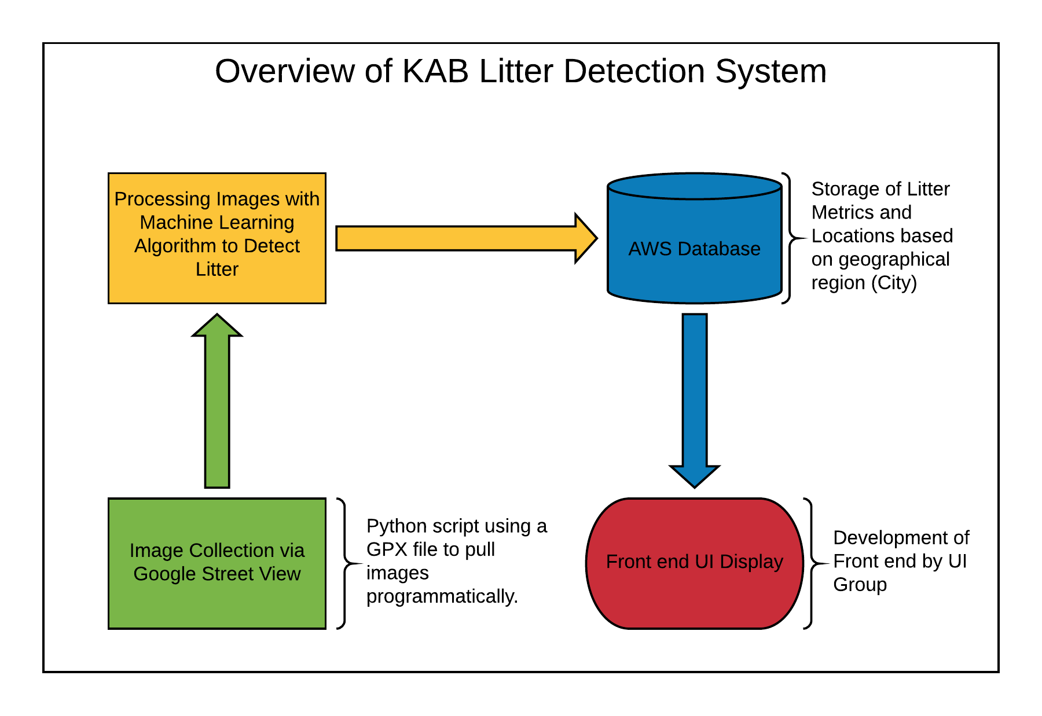

Table(s):

**Datapoint** ( datapoint_id, latitude, longitude, level_of_litter, num_litter_pieces, date_taken )

**ERD**

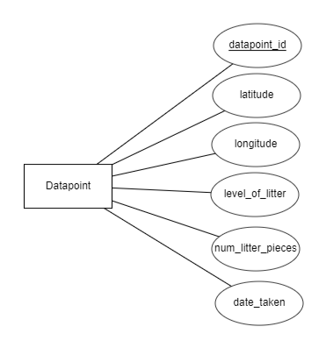

CREATE TABLE Datapoint (

datapoint_id INT AUTO_INCREMENT,

latitude FLOAT,

longitude FLOAT,

level_of_litter INT,

num_litter_pieces INT,

date_taken DATE

);

# **2. Requirements Matrix**

|  |  |  |  |  |  |
| --- | --- | --- | --- | --- | --- |
| Req. ID | Requirement | Description | Critical | Implemented [Y/N] | Task ID |
| 1 | Image Collection | - Script will capture 360 View, Google Maps, Google Street images and Plotaroute. | H | Y | 5.6, 5.6.1 |
| 2 | Machine Learning Processing | - Algorithm will process 360 google images.  - Will indicate trash in images. | H | Y | 5.6.2 |
| 3 | Organize Data from Algorithm into final product | - Algorithm will transfer data to database.  - Will organize into specified fields: total litter, litter rating, latitude, longitude, and date taken. | H | N | 7.7, 7.7.3, 8.5, 8.5.1 |

# **3. Project Management**

## 3.1 Product Breakdown Structure

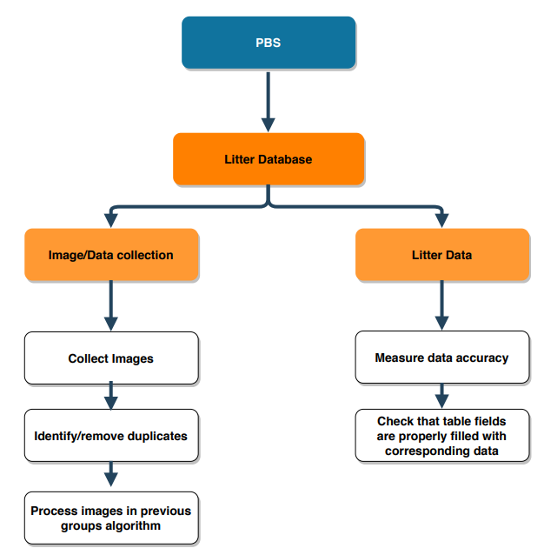

## 3.2 Work Breakdown Structure

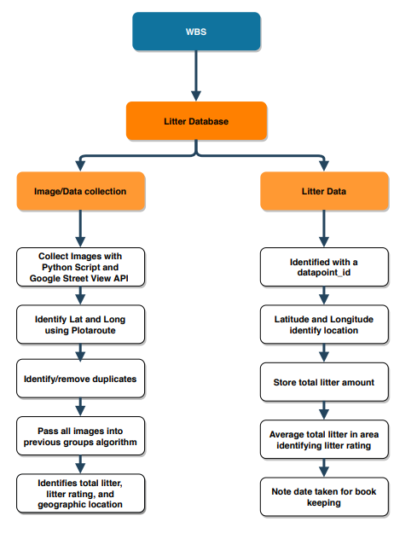

## 3.3 Initial Schedule for Tasks and Deliverables

**Schedule of Tasks:**

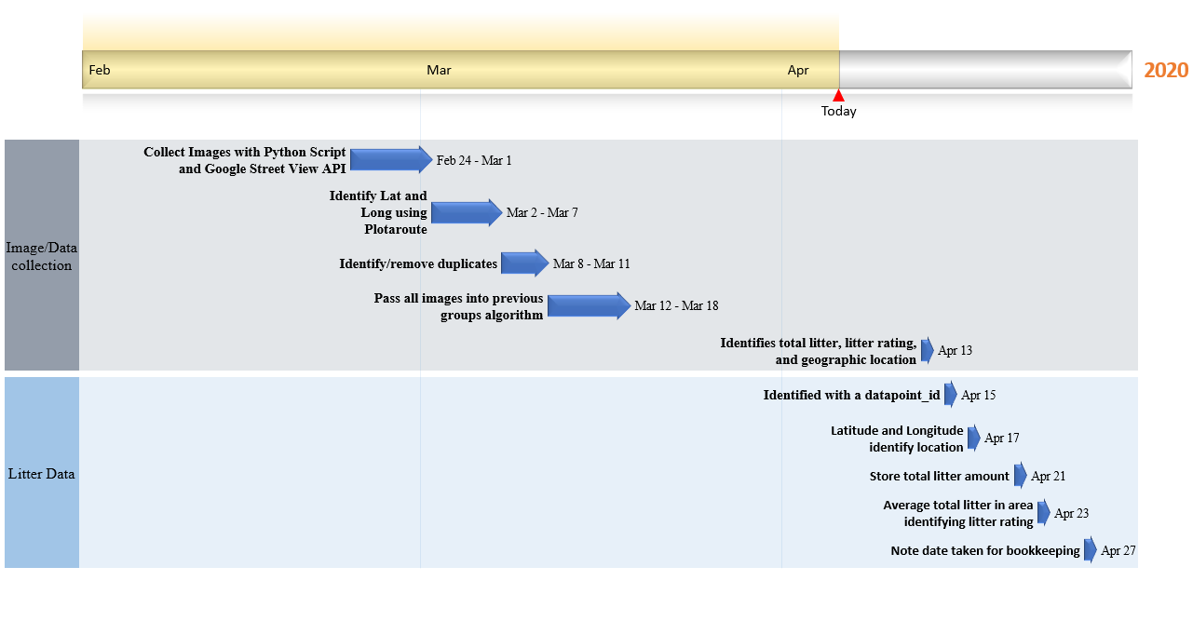

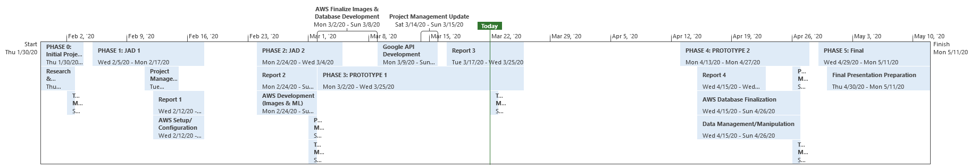

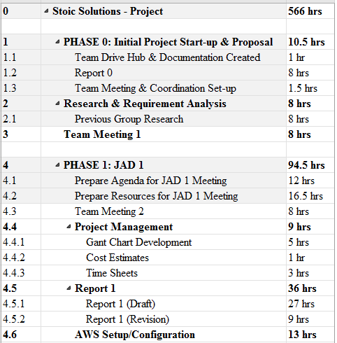

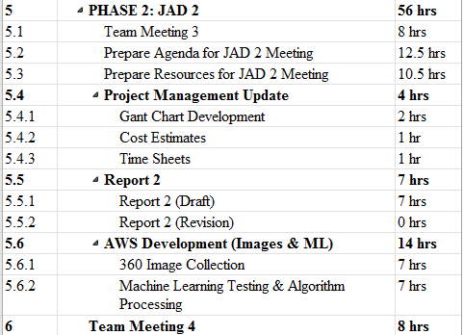

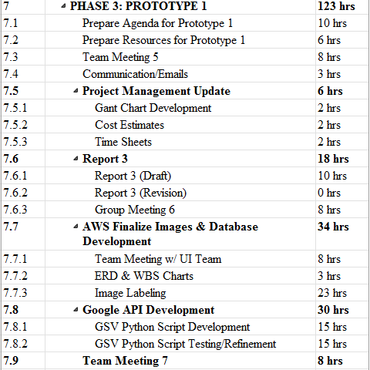

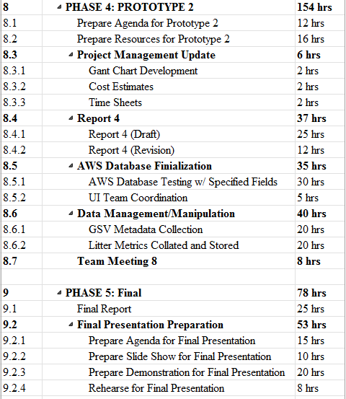

## 3.4 Statement of Total Price

As stated in our initial letter and agreement, the team will be operating at a rate of $28.00 per hour for each member of Stoic Solutions. The AWS server will cost .29 cents per hour to run. Altogether, the estimated cost of the entire project with the actual costs of Phase 1, 2 and 3 calculated is $15,889.10‬.

## 3.5 Gantt Chart

Our Gantt chart hours project actual hours for PHASE 0, 1, 2, and 3. Projected hours for PHASE 4 and 5 are purely estimated in correlation to our current workflow and timeline.

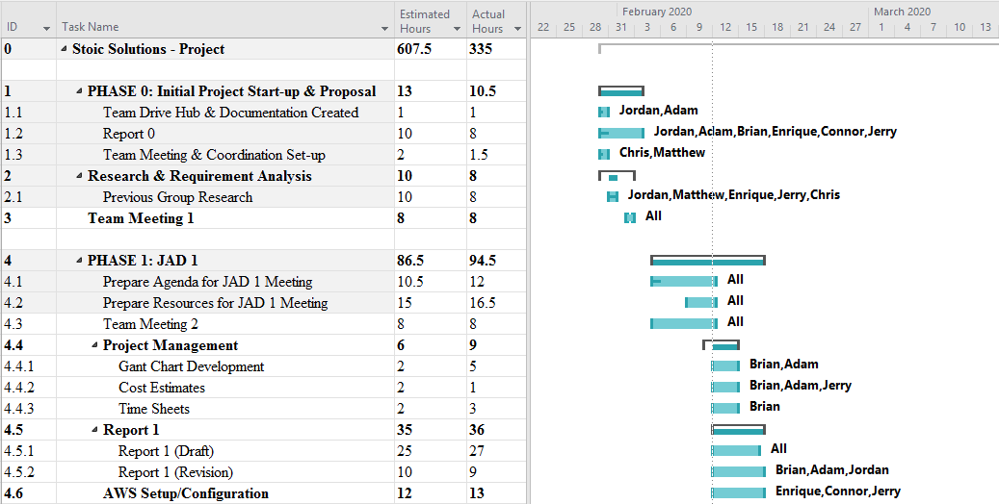

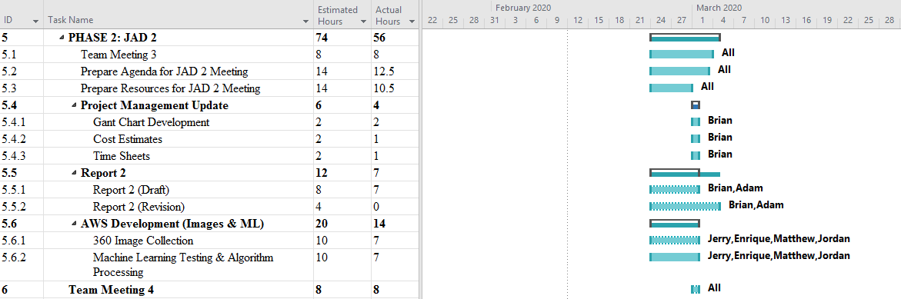

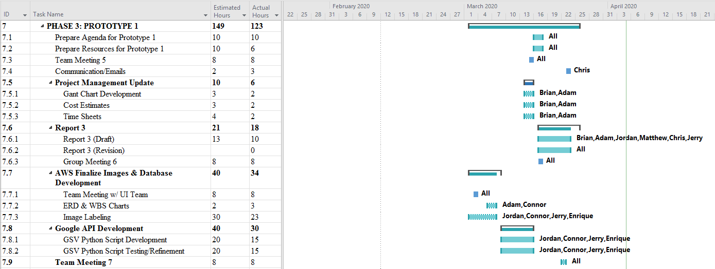

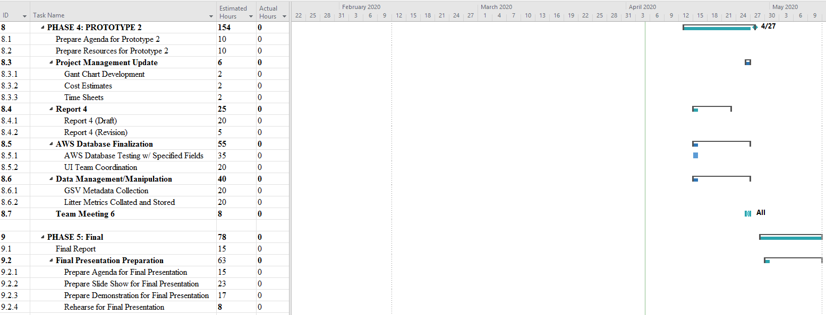

## 3.6 Initial Project Cost Tracking Chart

Below are the costs accumulated based on the team’s total hours worked. AWS was not configured entirely for Phase 0 & 1 but is represented and accrued at later phases. We did not need to run the AWS server during Phase 3 due to Phase 3 focusing on fine tuning image collection.

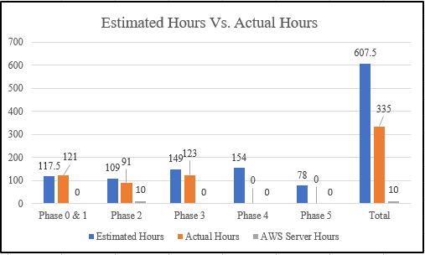

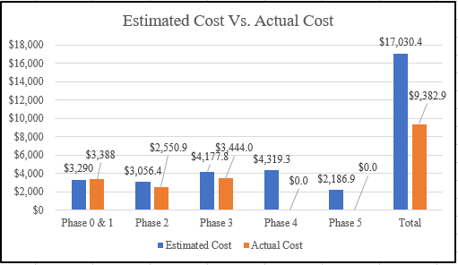

## 3.7 Statement of Deliverables

The Stoic Solutions team strives to deliver the following final products:

* A defined geographic location labelled for each set of 4 images produced from 360 google street images.
* Concise data base filled with litter count in given areas, rating, and geographical location.
* An updated report, including the goals and milestones we’ve reached and all documentation.
* Database documentation and access for the UI team to make use of.

The next phase is estimated to cost an additional $4,319.30 for the second prototype. The second prototype will result in a database filled with data gathered from the images we pulled from Prototype 1 (Phase 3) and will be used to finalize the project in Phase 4 (expected 4/27/20).

## 3.8 Outline of Resources Needed

The following resources are what the Stoic Solutions team will be supplying:

* Extensive Knowledge of AWS and database implementation.
* Updated documentation.
* Research and testing.
* Database credentials and access.

The following resources are what the Stoic Solutions team will need supplied from Dr. Stewart:

* Source code from previous team (Machine learning system).
* AWS Server Instance and Funding.
* Possible extra student labour to gather images since we will be doing a 360-view requiring 4 images rather than 1.
* Signage and approval for the Stoic Solutions team to continue working on the project.
* Availability for future meetings.